

INTELLIGENT CONVERSATIONAL AI CHATBOT WITH DOMAIN KNOWLEDGE INTEGRATION FOR HEALTHCARE

A CAPSTONE PROJECT REPORT

A Capstone Project Report submitted in partial fulfilment of the requirements for the Course of

CSA1710 – ARTIFICIAL INTELLIGENCE
to the award of the degree of

BACHELOR OF ENGINEERING

IN

Computer Science and Engineering

Submitted by
G. Pallavi (192311208)
P. Harshitha (192312506)
M. Shakthi (192312538)

Under the Supervision of
Dr. B. Nagarajan
SIMATS ENGINEERING
Saveetha Institute of Medical and Technical Sciences Chennai-602105
SEPTEMBER 2026

SIMATS ENGINEERING
Saveetha Institute of Medical and Technical Sciences Chennai-602105

BONAFIDE CERTIFICATE

This is to certify that the Capstone Project entitled “Intelligent Conversational AI Chatbot with Domain Knowledge Integration for Healthcare” has been carried out by G. Pallavi (192311208), P. Harshitha (192312506), and M. Shakthi (192312538) under the supervision of Dr. B. Nagarajan and is submitted in partial fulfilment of the requirements for the B.Tech Electronics and Communication Engineering program at Saveetha Institute of Medical and Technical Sciences, Chennai.

COURSE COORDINATOR COURSE FACULTY
Dr. Krishna kumar kathiresan, Dr. Nagarajan B,
Professor Professor
Generative AI Programming
SIMATS Engineering, SIMATS Engineering,
SIMATS, Chennai – 602105. SIMATS, Chennai – 602105.

SIMATS ENGINEERING
Saveetha Institute of Medical and Technical Sciences Chennai-602105

DECLARATION

I, P. Harshitha (192312506) of the Department of computer Science and Engineering, SIMATS Engineering, hereby declare that the Capstone Project Work entitled “Intelligent Conversational AI Chatbot with Domain Knowledge Integration for Healthcare” is my academic project work. The sources, software, datasets, computational resources and AI-assisted tools used have been appropriately acknowledged.

Place: Saveetha School of Engineering
Date: September 2026

Signatures of the Student:
P. Harshitha

SIMATS ENGINEERING
Saveetha Institute of Medical and Technical Sciences Chennai-602105

Individual Contribution Statement

Student Name / Register No. | Specific  Responsibilities | Design & Development Contribution | Testing & Analysis  Contribution | Report Contribution | Approx.  Contribution (%)
G. Pallavi  192311208 | Module 1 – Knowledge Integration | Collection, preprocessing, retrieval | Retrieval verification | Module 1 sections | 33.33%
P. Harshitha  192312506 | Module 2 – Query Processing | Intent/entity/context processing | Query verification | Module 2 sections | 33.33%
M. Shakthi  192312538 | Module 3 – Intelligent Response & Assistance | Response generation, context, safety | Relevance/context/safety testing | Module 3  sections | 33.34%
Total |  |  |  |  | 100%

ABSTRACT

The project addresses the engineering problem of obtaining understandable, relevant, reliable, and context-aware healthcare information through conventional search methods and generic chatbots. Conventional search systems often provide large amounts of information without properly understanding the user’s specific question, while generic chatbots may generate responses that are insufficiently grounded in trusted healthcare knowledge, difficult for users to understand, or weak in maintaining context during multi-turn conversations. Therefore, there is a need for an intelligent healthcare information system that can provide quick, relevant, understandable, and responsible responses to users. The proposed solution is an Intelligent Conversational AI Chatbot with Domain Knowledge Integration for Healthcare, which combines healthcare-domain knowledge, Natural Language Processing (NLP), embedding-based retrieval, conversation context, and a Large Language Model (LLM) through a Retrieval-Augmented Generation (RAG) workflow. In this system, the user’s query is first processed to understand its meaning and identify the required healthcare information. The processed query is then used to retrieve relevant information from a healthcare knowledge base using embedding-based retrieval techniques. The retrieved knowledge is provided to the conversational generation module along with the user’s conversation history so that the system can understand both the current query and the context of previous interactions. Module 3 receives the processed query and the retrieved healthcare knowledge, incorporates the relevant conversation history, and generates a natural-language response that is clear and understandable to the user. After generating the response, the system performs relevance checking to ensure that the response is related to the user’s query and is supported by the retrieved knowledge. The system also applies healthcare safety rules to reduce the possibility of providing inappropriate or unsafe information. If the conversation indicates a potentially high-risk health situation, the chatbot recommends that the user seek assistance from a qualified healthcare professional rather than depending only on the chatbot. The overall methodology follows a sequence of query processing, healthcare knowledge retrieval, context-aware response generation, relevance checking, safety validation, and final output generation. This workflow enables the chatbot to provide responses that are more relevant, contextual, knowledge-grounded, and safety-aware compared with conventional search systems and generic conversational systems. The major result of the proposed design is a healthcare conversational system capable of handling user queries by combining retrieved domain knowledge with conversation context and language-generation capabilities while applying appropriate safety measures. The system is intended to support users as a first-level healthcare information assistant by making healthcare information easier to access and understand. However, it is not designed to replace doctors, medical professionals, professional diagnosis, clinical judgment, or medical treatment. Overall, the proposed intelligent conversational healthcare chatbot provides a responsible approach to healthcare information assistance by integrating domain knowledge, NLP, embedding-based retrieval, conversational context, RAG, Large Language Models, relevance validation, and healthcare safety mechanisms, while ensuring that professional medical consultation is recommended whenever it is necessary.

TABLE OF CONTENTS

i | CERTIFICATE FROM THE SUPERVISOR | ii
ii | DECLARATION BY THE CANDIDATE | iii
Iii | INDIVIDUAL CONTRIBUTION STATEMENT | iv
iv | ABSTRACT | v
v | LIST OF FIGURES | vi
vi | LIST OF TABLES | vii
vii | LIST OF ABBREVIATIONS | viii
1 | CHAPTER 1: Introduction and Engineering Problem | 1
2 | CHAPTER 2: Literature Review and Existing Solutions | 3
3 | CHAPTER 3: Engineering Design & Trade-offs, Sustainability, Ethics, Safety, Risk & Security | 5
4 | CHAPTER 4: Implementation, Testing & Results, Project Management | 9
5 | CHAPTER 5: Conclusion, Future Work and Reflection | 13
 | References | 15
 | Appendices | 16
 | Appendices

LIST OF FIGURES

Figure No. | Figure Name | Page No.
Fig. 3.1 | Module 3 response-generation workflow | 6
Fig. 3.2 | Clean Module 3 safety/history/output flowchart | 7
Fig. 4.1 | System architecture / RAG workflow | 10
Fig. 4.2 | Module 3 implementation evidence | 10

LIST OF TABLES

Table  No. | Table Name | Page  No.
Table 2.1 | Review of existing work | 4
Table 3.1 | Stakeholder / user requirements | 5
Table 3.2 | Functional and non-functional requirements | 5
Table 3.3 | Constraints and applicable standards | 5
Table 3.4 | Design specifications | 6

CHAPTER 1

INTRODUCTION AND ENGINEERING PROBLEM
1.1 Background
Healthcare information has become increasingly accessible through the internet, search engines, websites, mobile applications, and conversational artificial intelligence systems. Users frequently search online for information related to symptoms, diseases, medicines, preventive healthcare, basic medical terminology, lifestyle practices, and general health-related concerns. However, the information available through conventional search methods is often distributed across multiple sources, presented using complex medical terminology, or difficult for non-technical users to interpret correctly. Users may also find it difficult to determine which information is relevant to their particular question.
The proposed project, Intelligent Conversational AI Chatbot with Domain Knowledge Integration for Healthcare, is designed to provide users with an accessible first-level healthcare information assistant. The system uses Natural Language Processing (NLP) to understand user queries and embedding-based retrieval to identify relevant information from a healthcare knowledge base. The retrieved information is then supplied to a Large Language Model (LLM) through a Retrieval-Augmented Generation (RAG) workflow to generate a meaningful and knowledge-grounded response. Conversation history is also considered so that the chatbot can understand follow-up questions and maintain continuity during multi-turn interactions. Module 3 receives the processed query and retrieved knowledge from the previous modules, incorporates relevant conversation context, and generates a clear, natural-language response. The generated response is then checked for relevance and subjected to healthcare safety rules before being presented to the user. This approach aims to reduce unsupported responses, improve contextual understanding, and make healthcare information easier to understand while maintaining appropriate safety boundaries.
Therefore, the project combines artificial intelligence, NLP, information retrieval, knowledge representation, conversational context management, and response validation into a single software-based healthcare information system.

1.2 Need for the Project
The project is needed because users increasingly depend on digital platforms for obtaining healthcare-related information, but existing approaches may not always provide information in a clear, contextual, and responsible manner. Healthcare terminology can be difficult for users without a medical background, and searching through multiple websites can require considerable time and effort. A conversational system can provide information in a more interactive manner by allowing users to ask questions using natural language and receive responses in an understandable format.
The major needs of the proposed project include the following:
- Quick access to healthcare information: Users require fast access to general information about symptoms, diseases, medicines, preventive care, and health-related concepts.
- Simplification of medical terminology: Many healthcare resources use technical terminology that may be difficult for ordinary users to understand. A conversational system can generate explanations using simpler and more understandable language.
- Improved information relevance: Conventional keyword-based searches may return a large number of results without understanding the complete intention behind the user's question. Domain-aware retrieval can identify information that is more closely related to the query.
- Context-aware interaction: Users may ask follow-up questions without repeating the complete context. Maintaining conversation history enables the system to understand such multi-turn interactions more effectively.
- Knowledge grounding: Generic language models may generate responses based on learned patterns without directly retrieving information from a specific knowledge source. Retrieval-Augmented Generation provides relevant healthcare information to the language model before response generation.
- Healthcare safety: Healthcare-related responses require additional safety considerations. The system should identify potentially high-risk situations and encourage users to consult qualified healthcare professionals rather than presenting the chatbot as a diagnostic authority.
- User-friendly interaction: A conversational interface allows users to interact with the system naturally instead of requiring them to understand complex search techniques or technical terminology.
- Responsible use of Artificial Intelligence: The project demonstrates how generative AI can be integrated into a sensitive application area while incorporating retrieval, validation, safety rules, and appropriate limitations.

1.3 Problem Statement
There is a need for a conversational healthcare information system capable of understanding natural-language queries, retrieving relevant healthcare-domain knowledge, maintaining conversational context, and generating clear and meaningful responses. Conventional search systems may provide fragmented information, while generic conversational systems may not provide sufficient domain grounding, may lose context during multi-turn conversations, or may generate responses that require additional verification. Therefore, the engineering challenge is to develop an integrated system that combines natural-language processing, healthcare knowledge retrieval, embedding-based semantic search, conversational context management, generative AI, relevance checking, and healthcare safety validation.
The problem involves the following engineering considerations:
- Multiple interacting factors: Query understanding, information retrieval, conversation history, language generation, relevance checking, and safety validation must work together.
- Technical complexity: The system requires integration of NLP, embeddings, vector-based retrieval, RAG, LLM-based generation, context management, and response validation.
- Conflicting requirements: The chatbot should provide useful and detailed information while avoiding unsafe, misleading, or overconfident medical guidance.
- Realistic engineering constraints: The design must consider computational resources, response time, knowledge-base limitations, model performance, retrieval accuracy, scalability, and system reliability.
- Safety constraints: The chatbot must clearly remain an informational assistant and should recommend professional consultation for potentially high-risk situations

1.4 Project Aim
The primary aim of the project is to develop an intelligent, context-aware, and knowledge-grounded healthcare chatbot that integrates healthcare-domain knowledge with Conversational AI to provide relevant, understandable, and safety-conscious healthcare information to users.
The system aims to improve the way users interact with healthcare information by allowing them to communicate through natural-language queries rather than relying only on traditional keyword-based searches. It combines retrieval and generative techniques so that responses can be generated using relevant healthcare information while considering the context of the ongoing conversation. The system also aims to introduce safety validation mechanisms that help prevent the chatbot from being interpreted as a replacement for professional medical advice.

1.5 Project Objectives
The measurable objectives of the project are:
- To develop a conversational healthcare chatbot architecture consisting of interconnected modules for query processing, knowledge retrieval, context handling, response generation, and validation.
- To integrate healthcare-specific domain knowledge into the chatbot so that generated responses are supported by relevant healthcare information.
- To process natural-language queries using NLP techniques and identify the user's information requirements.
- To implement embedding-based knowledge retrieval for identifying semantically relevant healthcare information rather than depending only on exact keyword matching.
- To incorporate conversation context so that the chatbot can understand previous interactions and handle multi-turn conversations more effectively.
- To generate natural-language responses using an LLM supported by the information retrieved from the healthcare knowledge base.
- To improve response relevance and grounding by checking whether the generated response appropriately addresses the user's query and is consistent with the retrieved information.
- To implement healthcare safety rules for identifying potentially inappropriate, sensitive, or high-risk situations.
- To recommend professional consultation when a user's query indicates a potentially serious or high-risk healthcare situation.

1.6 Scope
The scope of the project covers the development of a software-based conversational healthcare information assistant using domain knowledge, NLP, retrieval techniques, conversational context, and generative AI. The system is primarily focused on providing general healthcare information through a natural-language conversational interface.
The scope can be summarized as follows:
- Healthcare information queries and general health-related assistance.
- Natural-language query understanding and processing.
- Healthcare-domain knowledge integration.
- Semantic or embedding-based information retrieval.
- Retrieval-Augmented Generation using an LLM.
- Multi-turn conversational context management.
- Context-aware response generation.
- Response relevance and consistency checking.
- Healthcare safety-rule implementation.
- Professional consultation recommendations for potentially high-risk situations.
- User-friendly conversational interaction.
- Software-level prototype implementation and evaluation.

1.7 Expected Engineering Outcome
The expected engineering outcome of the project is a software-based intelligent conversational healthcare information assistant capable of receiving natural-language healthcare queries, retrieving relevant domain knowledge, considering conversation context, generating an understandable response, and applying safety validation before displaying the response to the user.
The expected engineering outcome can be described as follows:
- System: A three-module conversational healthcare AI architecture integrating query processing, healthcare retrieval, context management, generation, and validation.
- Product: A user-facing intelligent healthcare chatbot capable of providing general healthcare information through natural-language interaction.
- Process: The overall processing pipeline follows Query → Query Processing → Healthcare Knowledge Retrieval → Context Integration → Response Generation → Relevance Checking → Safety Validation → Final Output.
- Prototype: A functional software-level prototype demonstrating the integration of healthcare-domain knowledge with conversational AI.
- Algorithm: Retrieval-grounded, context-aware response generation using semantic retrieval and generative AI.
- Model: A Large Language Model supported by relevant healthcare knowledge retrieved through the RAG framework.
- Knowledge Base: A structured collection of healthcare-domain information used to provide supporting knowledge for response generation.
- NLP Component: Natural Language Processing techniques are used to interpret user queries and prepare them for retrieval and generation.
- Retrieval Component: Embedding-based semantic retrieval is used to identify information that is relevant to the meaning of the user's query.
- Context Component: Conversation history is incorporated to support continuity and improve understanding during multi-turn interactions.
- Validation Component: Generated responses are checked for relevance and subjected to predefined healthcare safety rules.
- Safety Mechanism: Potentially high-risk situations are identified where possible, and the user is encouraged to seek professional healthcare assistance.
- User Interface: A conversational interface allows users to communicate with the system using natural language.
- Device: Not applicable, as the proposed system is primarily a software-based solution.
- Engineering Benefit: The system provides a structured approach for combining retrieval-based knowledge and generative AI to produce more relevant, contextual, understandable, and safety-conscious healthcare information.

CHAPTER 2
LITERATURE REVIEW AND EXISTING SOLUTIONS

  - Review Method

The review was based on the research themes and sources identified in the project presentation: medical chatbots, healthcare intent classification, knowledge-grounded generation, hallucination risks and context-aware conversational agents.
  - Review of Existing Work
Relevant work included:
• Medical chatbot architectures.
• Healthcare intent classification.
• Knowledge-grounded medical dialogue.
• Generative AI / LLM response systems.
• Context tracking for multi-turn interaction.
• Safety and hallucination risks.
  - Comparative Analysis

Existing Approach | Advantages | Limitations | Relevance to Proposed Work
Rule-based chatbot  Generic LLM chatbot | Predictable scripted output  Strong conversational fluency | Limited flexibility/context  Healthcare grounding may be weak | Motivates natural-language generation, RAG and safety validation

  - Research / Engineering Gap

Existing healthcare chatbots and AI systems can provide healthcare information, but they may have limitations in knowledge grounding, context handling, response accuracy, and safety validation. Generic LLMs can generate fluent responses but may produce unsupported or inaccurate information, while traditional search systems may not understand the context of follow-up questions. There is also a need for better integration of healthcare-domain knowledge, semantic retrieval, conversational context, and safety mechanisms in a single system. Therefore, the proposed project addresses this engineering gap by developing a RAG-based conversational healthcare chatbot that retrieves relevant knowledge, maintains conversation context, validates responses, and recommends professional consultation for potentially high-risk situations.

  - Proposed Contribution
The proposed project contributes a knowledge-grounded and context-aware conversational healthcare chatbot that integrates healthcare-domain knowledge with a Large Language Model using a Retrieval-Augmented Generation (RAG) approach. It combines natural-language query processing, semantic knowledge retrieval, conversation history, response generation, relevance checking, and healthcare safety validation within a modular architecture. The system aims to improve the relevance and understandability of healthcare information while reducing unsupported responses. It also introduces a safety mechanism that recommends professional medical consultation for potentially high-risk situations, ensuring that the chatbot functions as an informational assistant rather than a replacement for professional diagnosis or treatment.

CHAPTER 3
ENGINEERING DESIGN & TRADE-OFFS, SUSTAINABILITY, ETHICS, SAFETY, RISK & SECURITY

  - Requirements
Stakeholder / User Requirements
Stakeholder | Requirement
Patient / General User  System Administrator  Project Team  Healthcare Professional | Clear, understandable healthcare information.  Controlled knowledge/response pipeline.  Integrated retrieval, processing, generation and safety.  Informational role with professional referral when appropriate.
Functional & Non-Functional Requirements
Requirement | Type  (Functional/non-functional) | Measurable Target
Natural-language response  Retrieved knowledge use  Conversation context  High-risk detection  User-friendly language  Response relevance  Safety | Functional  Functional  Functional  Functional  Non-Functional  Non-Functional  Non-Functional | Response for valid query  Retrieved context included  Previous relevant turn used  Safety rule evaluated  Simple terminology  Addresses processed intent  No diagnosis/replacement claim

  - Constraints & Applicable Standards
Standard / Code | Requirement | How Applied in This Project
Technical  Safety / ethical  Domain  Context | Ground responses in retrieved knowledge.  Do not present chatbot as diagnostic authority.  Knowledge coverage may be incomplete. | Retrieved context supplied before generation.  Safety validation and professional referral.  Scope limited to available healthcare knowledge.

  - Design Specifications
Parameter | Target/Requirement | Unit | Priority
Response relevance  Context continuity  Knowledge grounding  Safety handling  Readability | Address processed intent  Use relevant prior context  Use retrieved healthcare knowledge  Apply rules before output  Clear user-friendly language | Qualitative  Qualitative  Qualitative  Qualitative  Qualitative | High  High  High  High  Medium

  - Alternative Solutions & Evaluation

Rule-based templates are predictable and simple, but have limited conversational flexibility. A generic LLM offers fluent responses but may lack healthcare grounding when used alone.
RAG + LLM combines retrieval with natural-language generation. It adds pipeline complexity but better supports grounding, context and responsible response handling.
Criterion | Weight | Alternative 1 | Alternative 2 | Alternative 3
Performance | 25% | Medium | High | High
Cost | 15% | High | High | Medium
Safety | 25% | Medium | Low | High
Sustainability | 15% | High | High | High
Reliability | 20% | Medium | Medium | High
  - Selected Design & Detailed Design
RAG-based response generation with an explicit safety-validation stage is selected because it best satisfies the project's requirements for grounding, context continuity, natural-language output and responsible healthcare assistance.
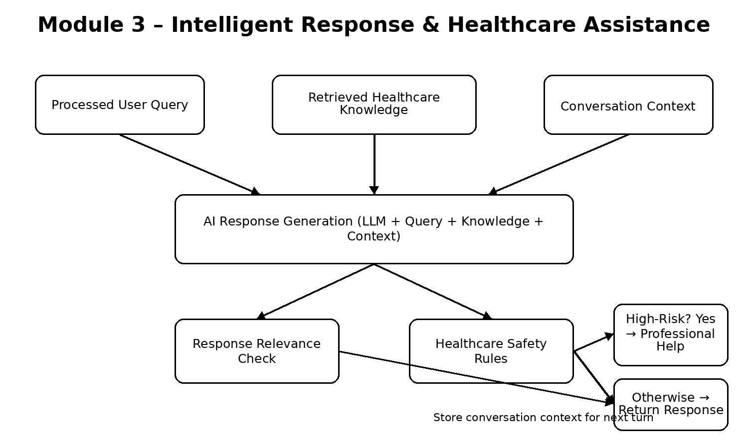
Module 3 receives the processed query from Module 2 and relevant healthcare knowledge from Module 1. Conversation history is added before generation. The AI model produces the response, which is checked for relevance and safety before output. Relevant context is retained for subsequent turns.
  - Trade-off Analysis
Design Decision | Alternative  Considered | Benefit | Disadvantage | Final Decision &  Justification
Response generation  Safety handling | Rule-based templates; Generic LLM  No explicit validation | Predictable; fluent  Simple | Limited flexibility; grounding risk  Unsafe output may pass | Select RAG + LLM for grounding/context.  Select explicit safety layer.

  - Sustainability, Ethics, Safety, Risk & Security
Domain | Consideration | Evidence Evaluated | Impact on Final  Decision
Sustainability  Ethics  Health & Safety  Security | Software-based, reusable knowledge resources.  Avoid misleading medical authority.  Detect potentially high-risk queries.  Protect conversation and knowledge resources. | Software chatbot architecture.  Presentation states informational role.  Module 3 safety workflow.  Queries, history and knowledge require control. | Lightweight digital implementation.  Safety wording built into output.  Mandatory validation/referral stage.  Controlled data handling.

Risk Register
Risk | Likelihood | Severity | Risk Level | Mitigation | Residual  Risk
Unsupported/hallucinated response  Misinterpretation  High-risk response  Incomplete knowledge | Medium  Medium  Low–Medium  Medium | High  Medium  High  Medium | High  Medium  High  Medium | Ground with retrieved knowledge; validate.  Use Module 2 intent/context.  Apply safety rules and professional referral.  Expand knowledge base and state limitations. | Medium  Low–Medium  Medium  Medium

CHAPTER 4
IMPLEMENTATION, TESTING & RESULTS, PROJECT MANAGEMENT

  - Development Approach & Resources
The development follows the three-module architecture in the presentation. Module 3 is designed around defined inputs from query processing and knowledge retrieval, followed by response generation, relevance checking, safety validation and context storage.
  - Hardware / Software / Fabrication Implementation & Modern Tools Used

Python supports chatbot logic; NLP/Transformer components support query processing; an LLM provides response generation; the knowledge base and embedding/vector retrieval provide context; and a web/mobile interface supports user interaction.

Tool / Software / Equipment | Purpose | Stage Used
Python  NLP / spaCy / Transformers  LLM / Generative AI  Knowledge Base / Database  Embedding / Vector Retrieval  Web / Mobile Interface | Chatbot/backend logic  Text processing/query understanding  Response generation  Healthcare knowledge storage  Semantic retrieval  User interaction | Across modules  Module 2  Module 3  Module 1  Module 1  System output

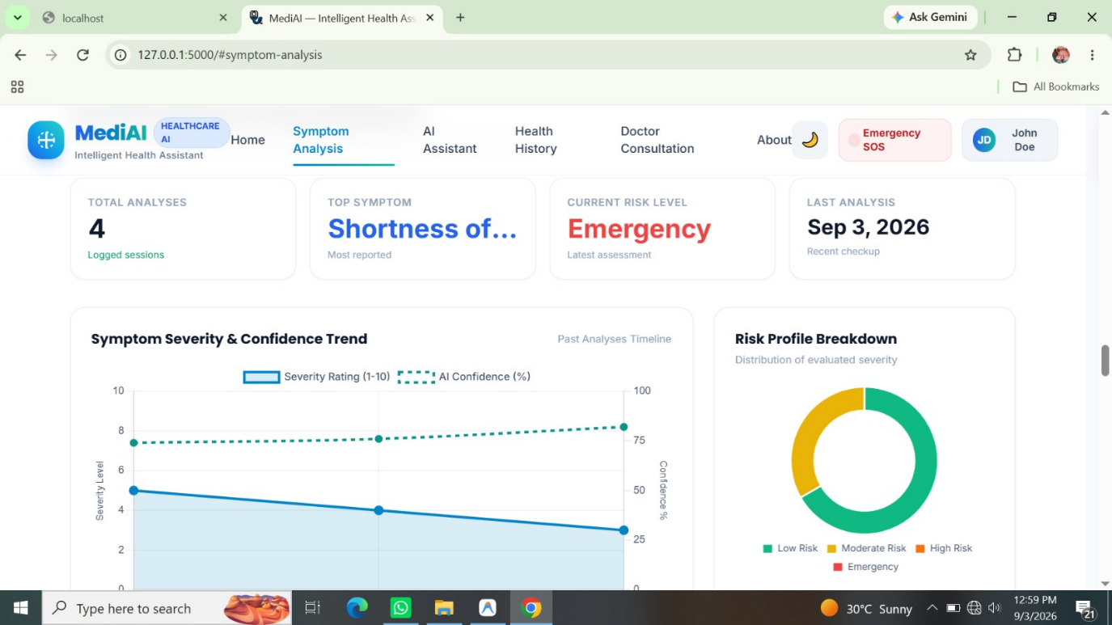
  - Test Plan & Verification

Requirement | Test Method | Acceptance Criterion
Valid processed query  Retrieved context available  Previous turn retained | Module 3 accepts input  Context reaches generation  Relevant prior context incorporated | All listed checks addressed at design level
Response relevance  Safety handling | Compare output with intent  Provide high-risk query category | Pass | Pass
User-friendly response | Review generated wording | Pass | Pass
  - Results

Verification checks query reception, knowledge grounding, context continuity, response relevance, safety handling and readability. The design-level verification indicates that the listed Module 3 objectives are addressed.

  - Data Analysis & Engineering Judgment
Grounding responses with retrieved knowledge reduces dependence on unsupported free-form generation. Context handling improves follow-up interaction, while the safety layer provides a control point before output. Quality remains dependent on knowledge coverage, retrieval quality and safety-rule design.
  - Comparison with Existing Solutions & Achievement of Objectives

Objective | Evidence | Achievement (Fully/Partially/Not  Achieved)
Healthcare chatbot  Healthcare knowledge  Natural-language processing  Context-aware responses  Conversation history  Safety-aware assistance | Three-module architecture  Module 1 retrieval  Module 2 NLP  Module 3 generation  Module 3 context  Safety rules + referral | Fully  Fully  Fully  Fully  Fully  Fully at design level

  - Strengths & Limitations
Strengths
  - Knowledge Grounding: Uses healthcare-domain knowledge to provide relevant and reliable responses.
  - Context Awareness: Maintains conversation history to give meaningful responses to follow-up questions.
  - Safety Validation: Applies safety rules and recommends professional help for high-risk situations.
  - Modular Architecture: Separates query processing, retrieval, generation, and validation into different modules.
Limitations
  - Incomplete Knowledge Coverage: May not cover every disease, medicine, or healthcare situation.
  - Response Validation Required: AI-generated responses may contain inaccurate or incomplete information.
  - Safety Rule Maintenance: Safety rules need regular updates to remain effective.
  - Not for Diagnosis: The chatbot provides general information and cannot replace professional medical diagnosis or treatment.
  - Project Planning, Roles & Budget

Milestones: requirements → literature review → architecture → Module 3 design → integration → testing → documentation/presentation.

Student | Assigned Responsibility | Actual Contribution
G. Pallavi | Module 1 – Knowledge Integration | Collection, preprocessing, retrieval
P. Harshitha | Module 2 – Query Processing | Intent, entity and context processing
M. Shakthi | Module 3 – Intelligent Response & Assistance | Response generation, context and safety validation

CHAPTER 5
CONCLUSION, FUTURE WORK AND REFLECTION

  - Conclusion
The project addresses the challenge of delivering understandable healthcare information through conversation. Its three modules integrate healthcare knowledge, query processing and intelligent response assistance. Module 3 combines retrieved knowledge, processed query and context, generates a response, checks relevance and applies safety rules. The approach supports responsible healthcare information assistance while retaining the need for professional consultation.
  - Future Work
Future work: expand healthcare specialties and regional guidelines; add multilingual and voice interaction; integrate wearable data; and introduce human-in-the-loop escalation for high-risk queries.

  - Professional Learning & Individual Reflection
• RAG and knowledge grounding
• Context-aware response generation
• Safety-aware healthcare communication
• Response validation
• NLP and conversational-system design
• Requirement analysis • Software architecture
• Testing and verification
• Technical documentation

Individual Reflection – M. Shakthi: The main engineering challenge in Module 3 was balancing helpful natural-language responses with healthcare safety. I addressed this by combining retrieved knowledge and conversation context before generation and applying a dedicated safety check.
    - A key decision was to use RAG with an explicit safety-validation stage instead of a standalone generic response model, because this directly addresses the grounding and safety gaps identified in the presentation.
    - I learned about retrieval-grounded generation, conversational context handling and the importance of separating informational assistance from diagnosis.
    - If repeated, I would make the safety rules and evaluation criteria more systematic and test them with a larger set of contextual and high-risk query cases.

REFERENCES

Amugongo, L. M., Mascheroni, P., Brooks, S. G., Doering, S., & Seidel, J. (2025). Retrieval augmented generation for large language models in healthcare: A systematic review. PLOS Digital Health, 4(6), e0000877.

Liu, S., McCoy, A. B., & Wright, A. (2025). Improving large language model applications in biomedicine with retrieval-augmented generation: A systematic review, meta-analysis, and clinical development guidelines. Journal of the American Medical Informatics Association, 32(4), 605–616.

Wang, L., Wan, Z., Ni, C., Song, Q., Li, Y., Clayton, E., Malin, B., & Yin, Z. (2024). Applications and Concerns of ChatGPT and Other Conversational Large Language Models in Health Care: Systematic Review. Journal of Medical Internet Research, 26, e22769.

Sallam, M. (2024). ChatGPT in healthcare: A taxonomy and systematic review. Computer Methods and Programs in Biomedicine, 245, 108013.

Liu, C., Pan, H., Yang, L., An, Y., Hu, Z., Zhang, Z., & Lau, A. S. M. (2025). Domain-Aware Healthcare Chatbot Incorporating BERT and RAG. Digitalization and Management Innovation IV.

Wang, Z., Li, H., Huang, D., Kim, H.-S., Shin, C.-W., & Rahmani, A. M. (2025). HealthQ: Unveiling questioning capabilities of LLM chains in healthcare conversations. Smart Health, 36, 100570.

Freyer, O., et al. (2024). A future role for health applications of large language models depends on regulators enforcing safety standards. The Lancet Digital Health, 6(9), e662–e672.

Arasteh, S. T., et al. (2024). RadioRAG: Factual Large Language Models for Enhanced Diagnostics in Radiology Using Dynamic Retrieval Augmented Generation. arXiv preprint arXiv:2407.15621.

Luo, M.-J., et al. (2024). Development and evaluation of a retrieval-augmented large language model framework for ophthalmology. JAMA Ophthalmology.

[2025]. Retrieval-Augmented Generation (RAG) in Healthcare: A Comprehensive Review. AI, 6(9), 226. The review covers RAG architecture, healthcare applications, evaluation metrics, retrieval instability, generation latency, domain shift, and transparency.

APPENDICES

Appendix A – Detailed Calculations
Appendix A – Module 2 workflow and design logic.
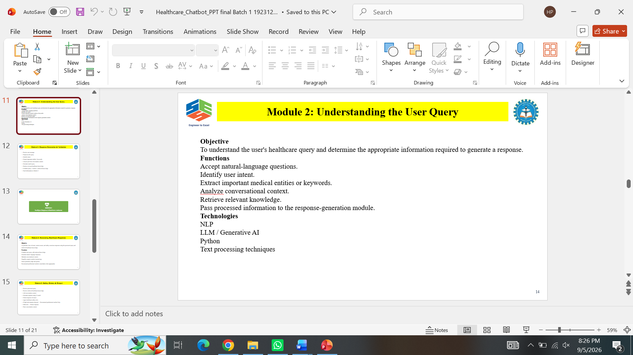
Appendix B – Clean Module flowchart.

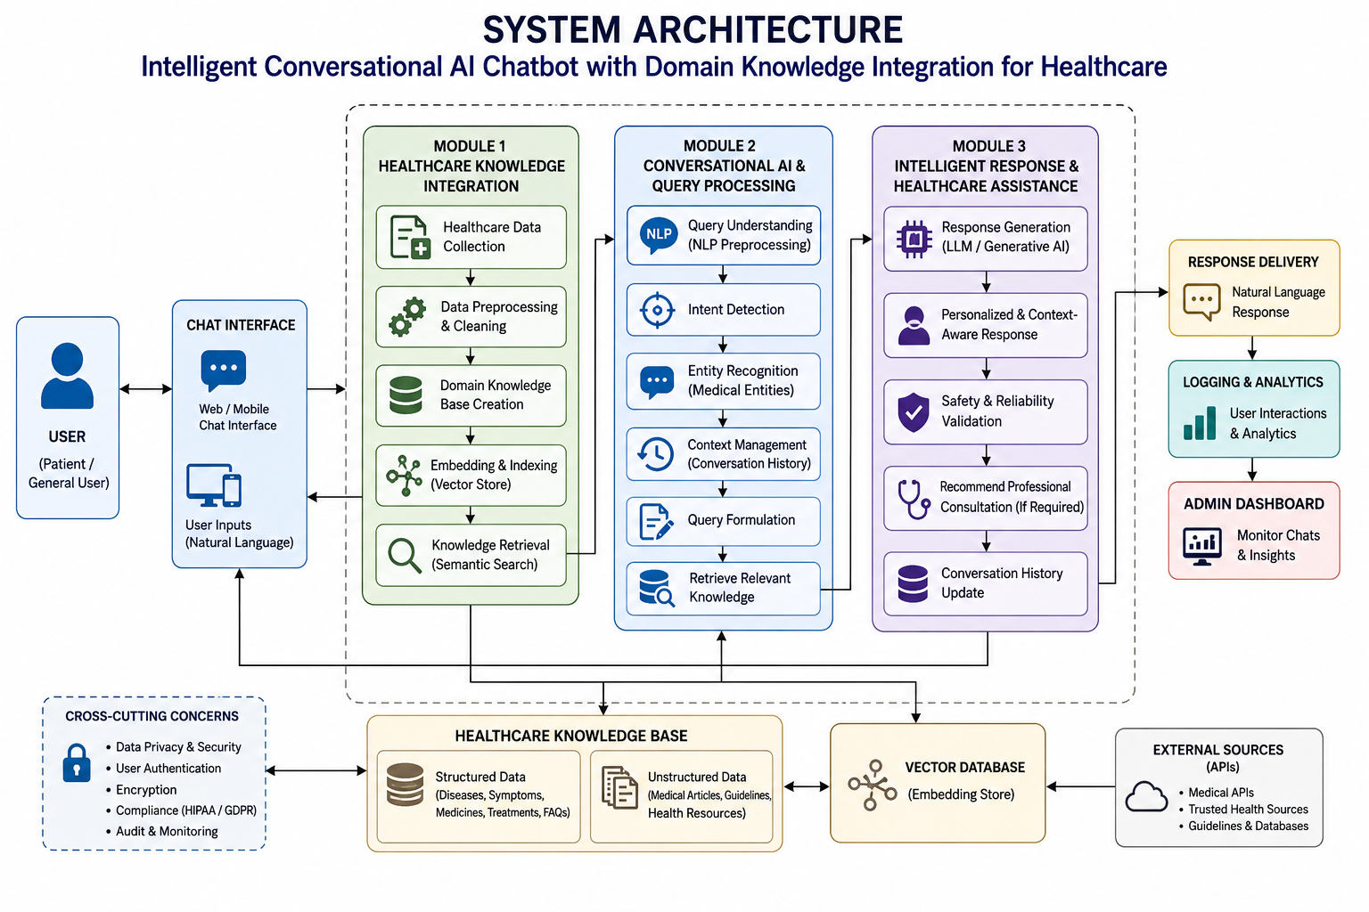

Appendix C – Source Code / Code Repository Information.
Only essential code excerpts should normally be included in the report. Complete source code may be maintained separately in the approved repository.
Appendix D – Software/tool information.
Appendix E – Verification observations.
Appendix F – Ethics / Institutional Approval.
Where applicable.
Appendix G – Project Meeting / Progress Records.
Appendix H – User/Industry Feedback.
Where applicable.
Appendix I – Publications / Patents / Competitions / Product Outcomes.
Where applicable.
Appendix J – Individual Contribution Evidence.
Module 3 evidence includes the response-generation design, safety/history/output flow, testing discussion and individual reflection.

